Nama : Ibnu Abdul Aziz Alqalibi

NPM : 5200411391

**Buat project baru**

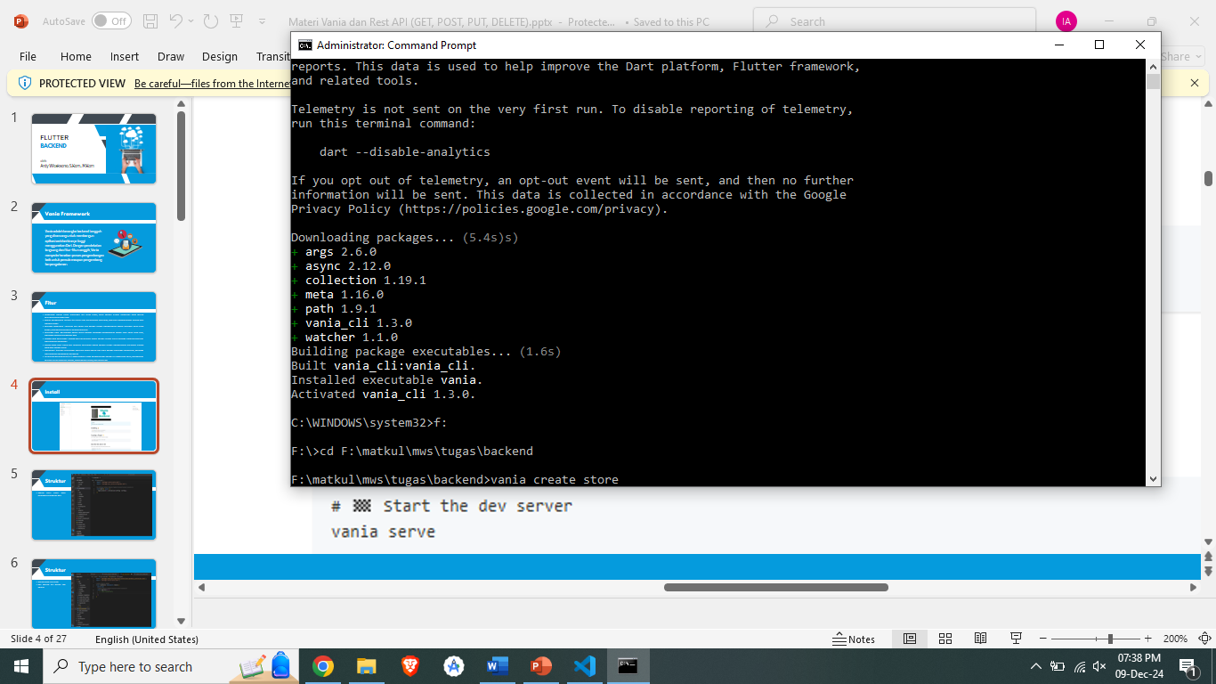

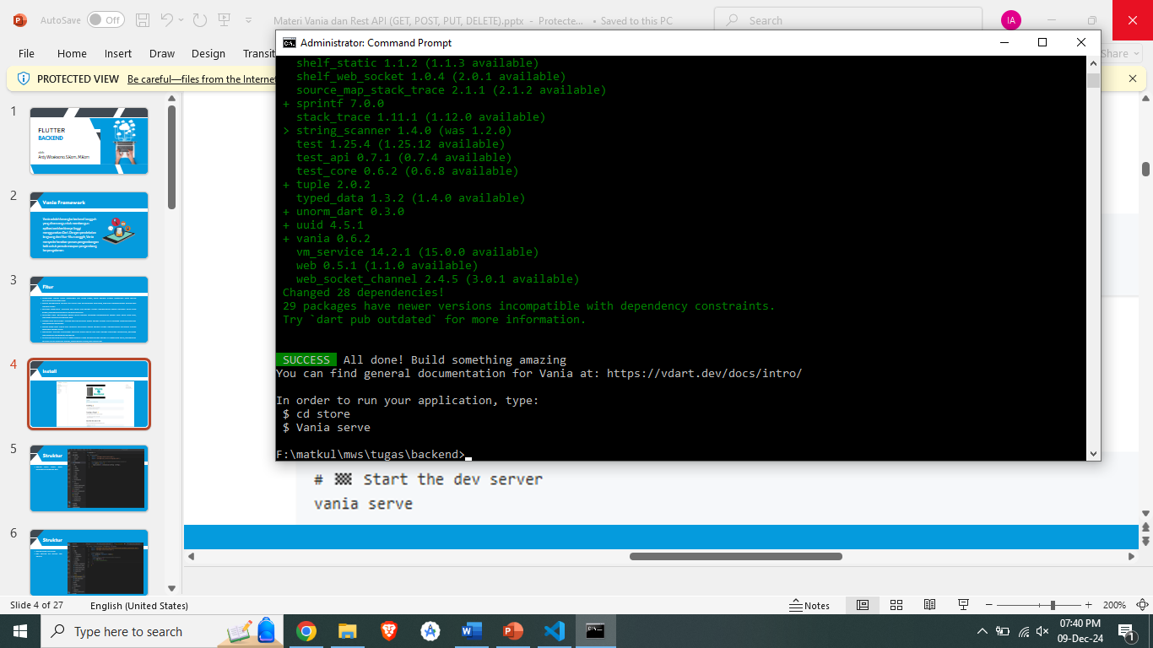

**Buat Migrations nya**

1. Table customers

1. Table orders

1. Table orderitems

1. Table vendors

1. Table products

1. Table productnotes

1. Ubah konfigurasi .env

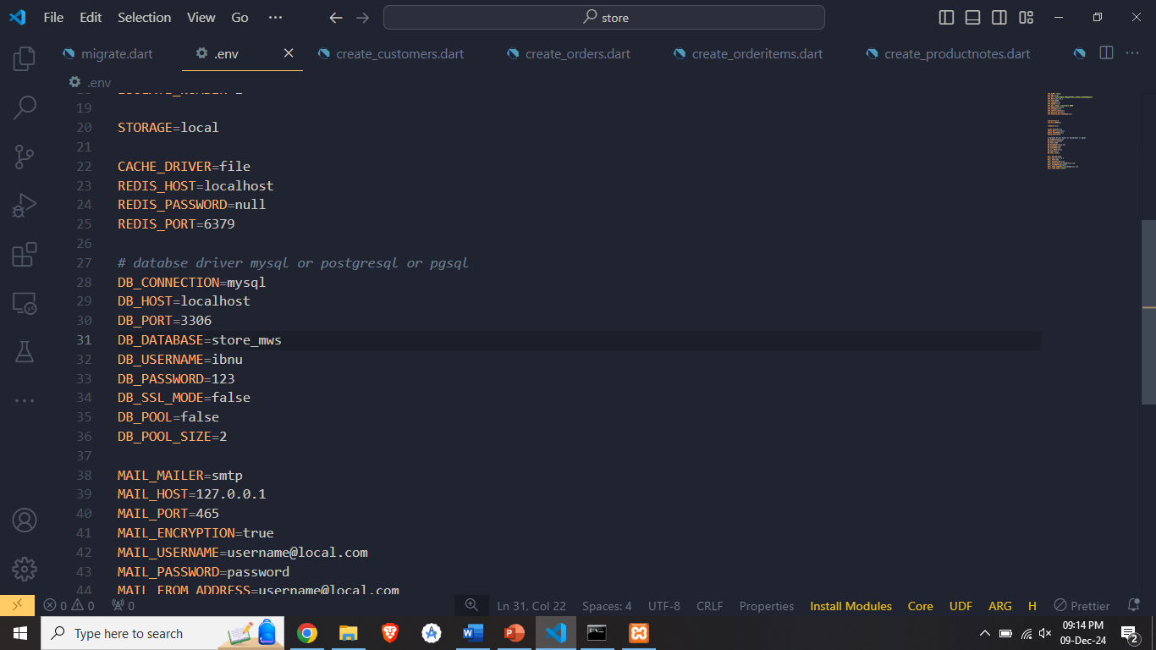

1. Create database

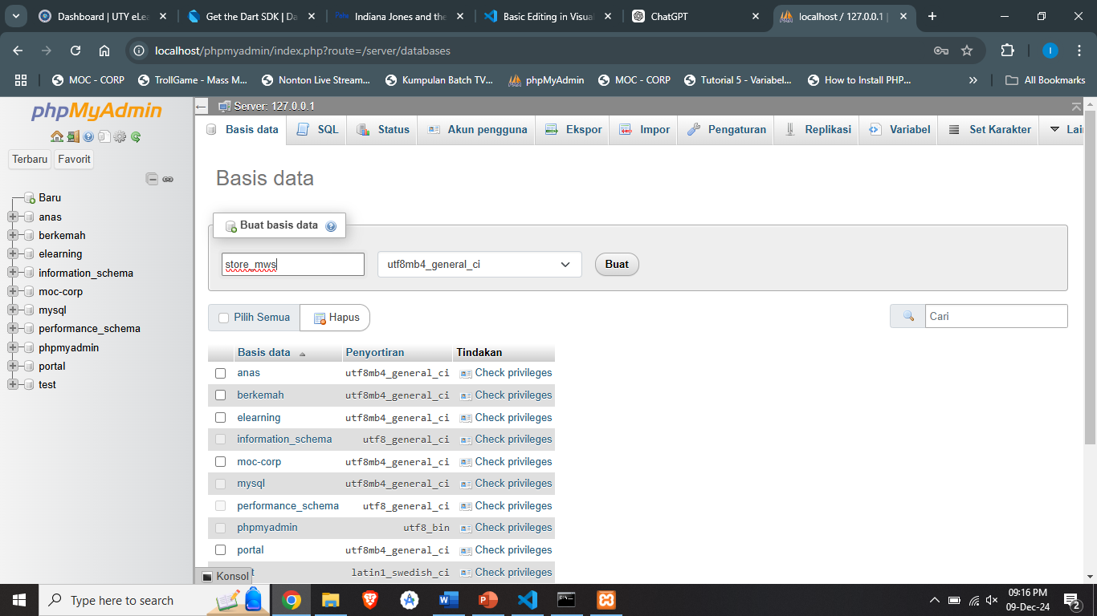

1. Migrate

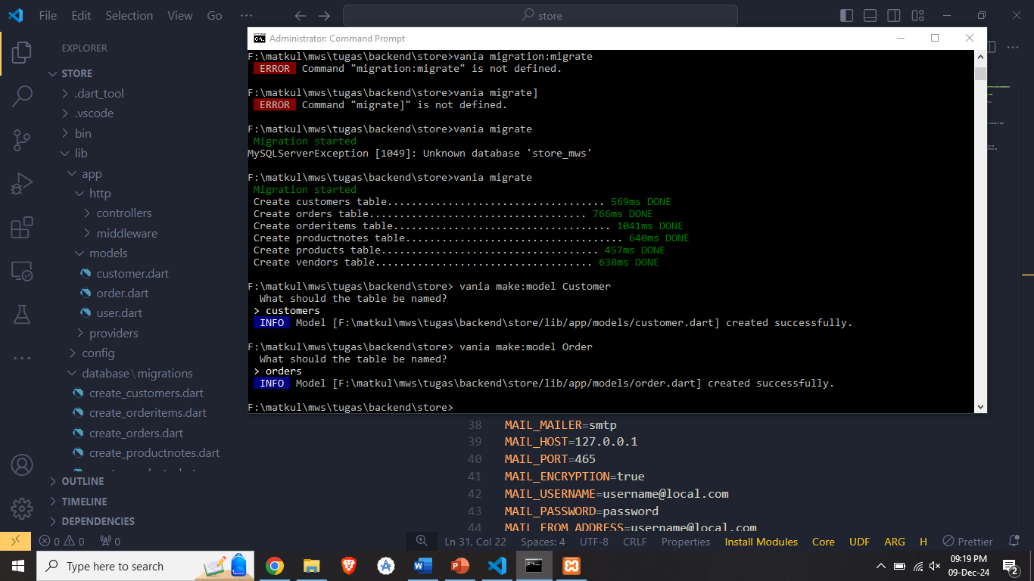

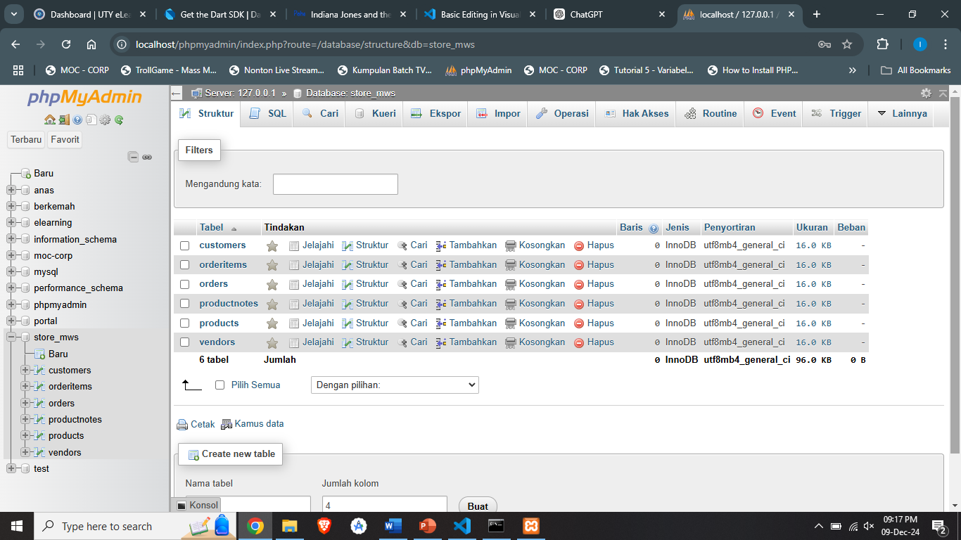

**Buat models**

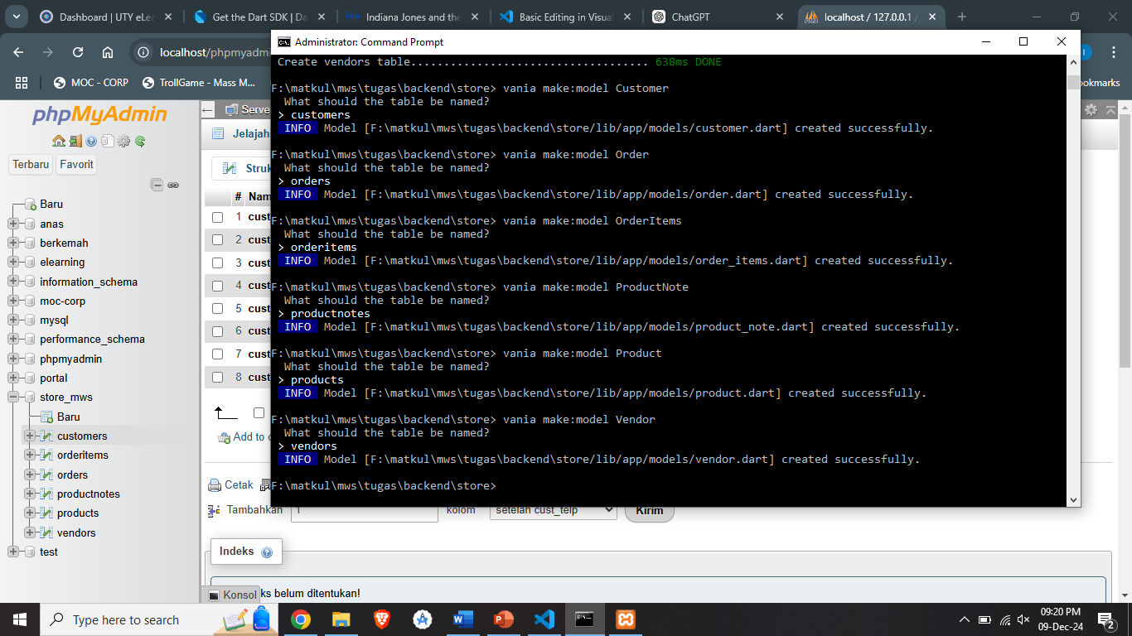

Hasil:

**Buat Controller**

1. Customer_controller

Index:

Store:

Update

Destroy:

1. Orders_controller

Index:

Store:

Update

Destroy:

1. Vendor_controller

Index:

Store:

Update

Destroy:

1. Product_controller

Index:

Store:

Update

Destroy:

1. Product_note_controller

Index:

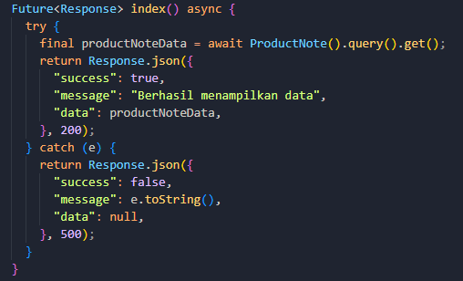

Store:

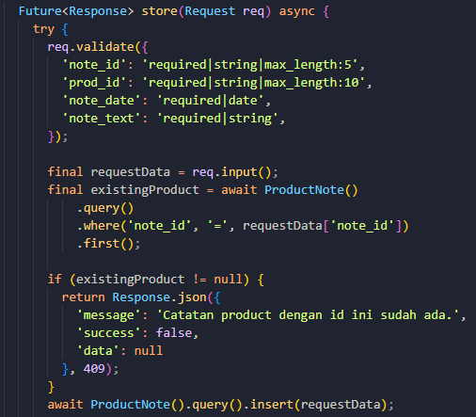

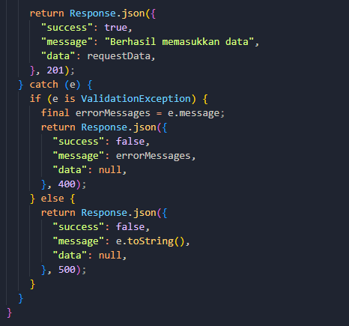

Update

Destroy:

1. Order_item_controller

Index:

Store:

Update

Destroy:

**Testing**

customers:

1. Create

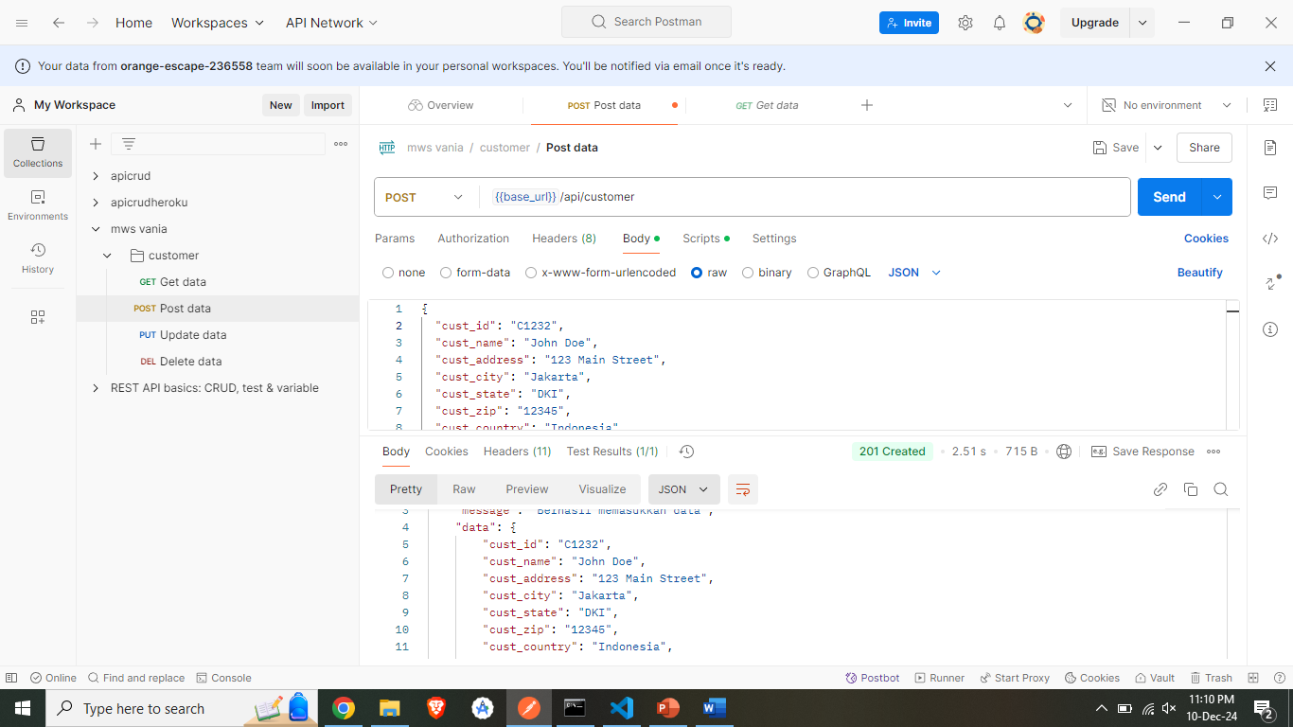

1. Read

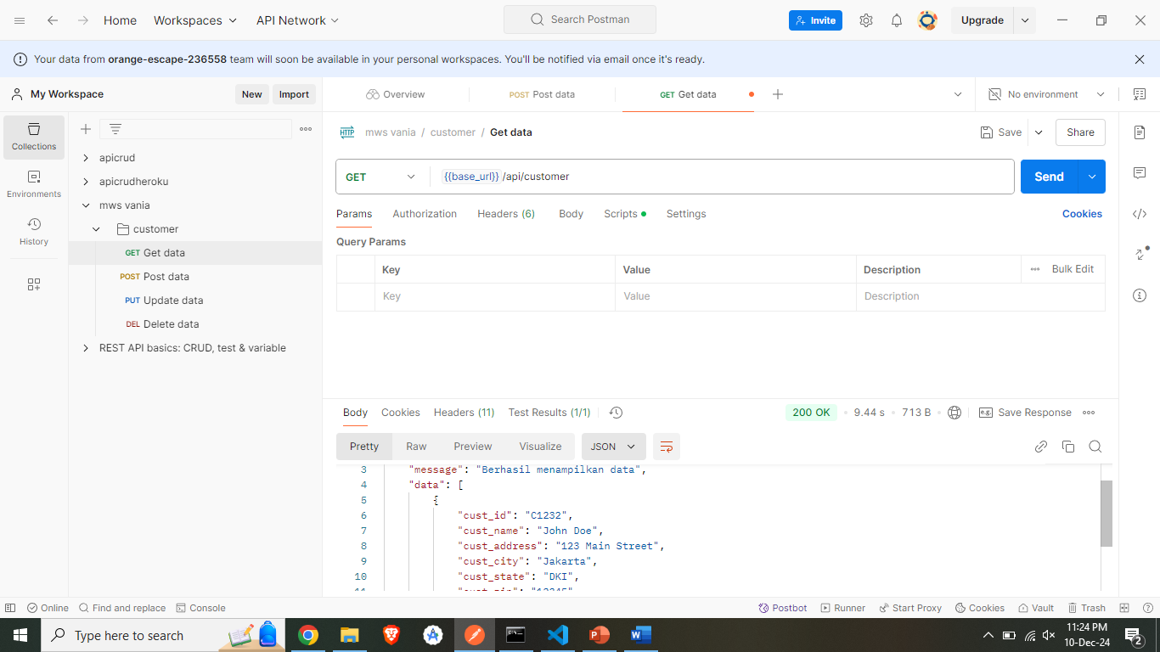

1. Update

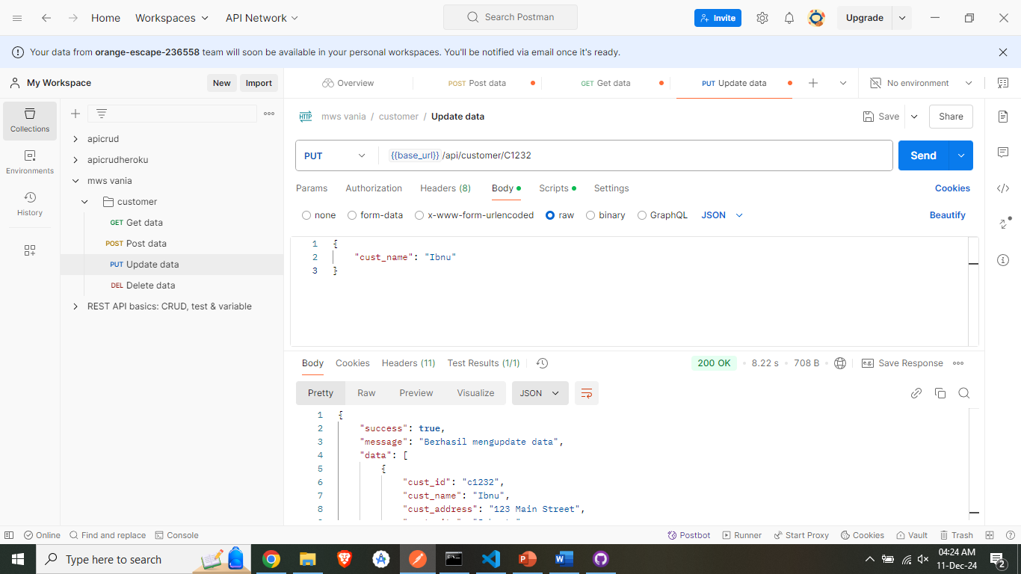

1. Delete

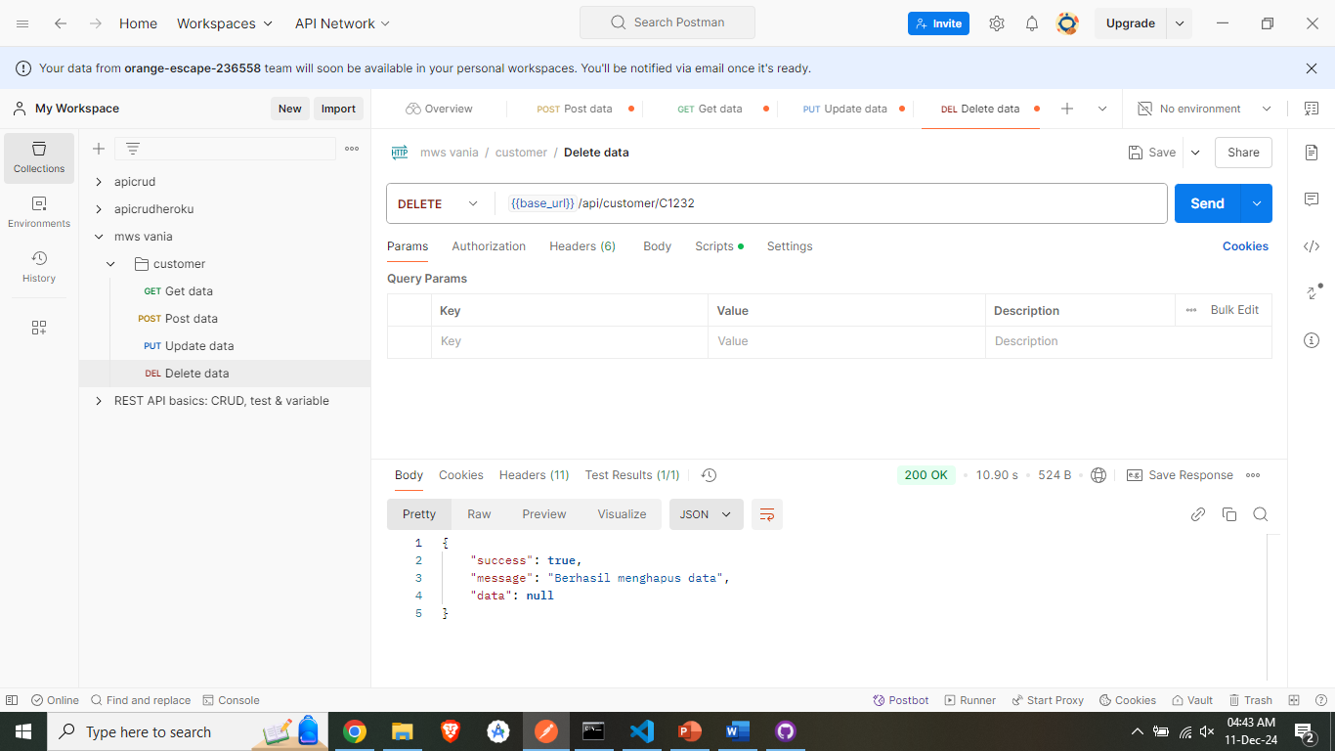

orders:

1. Create

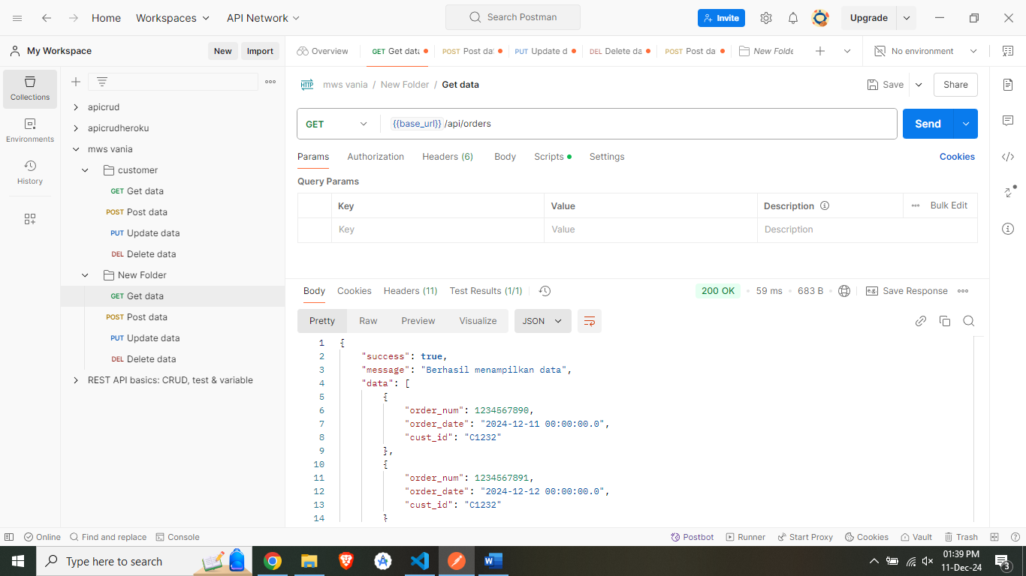

1. Read

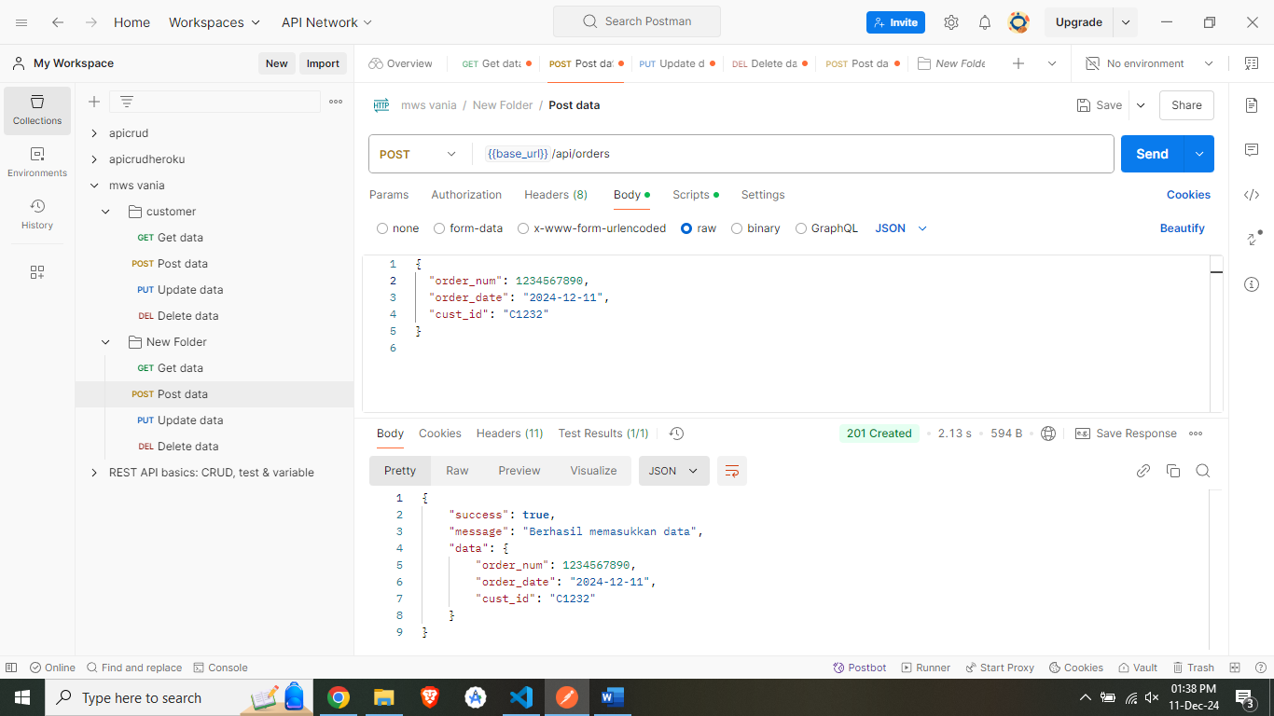

1. Update

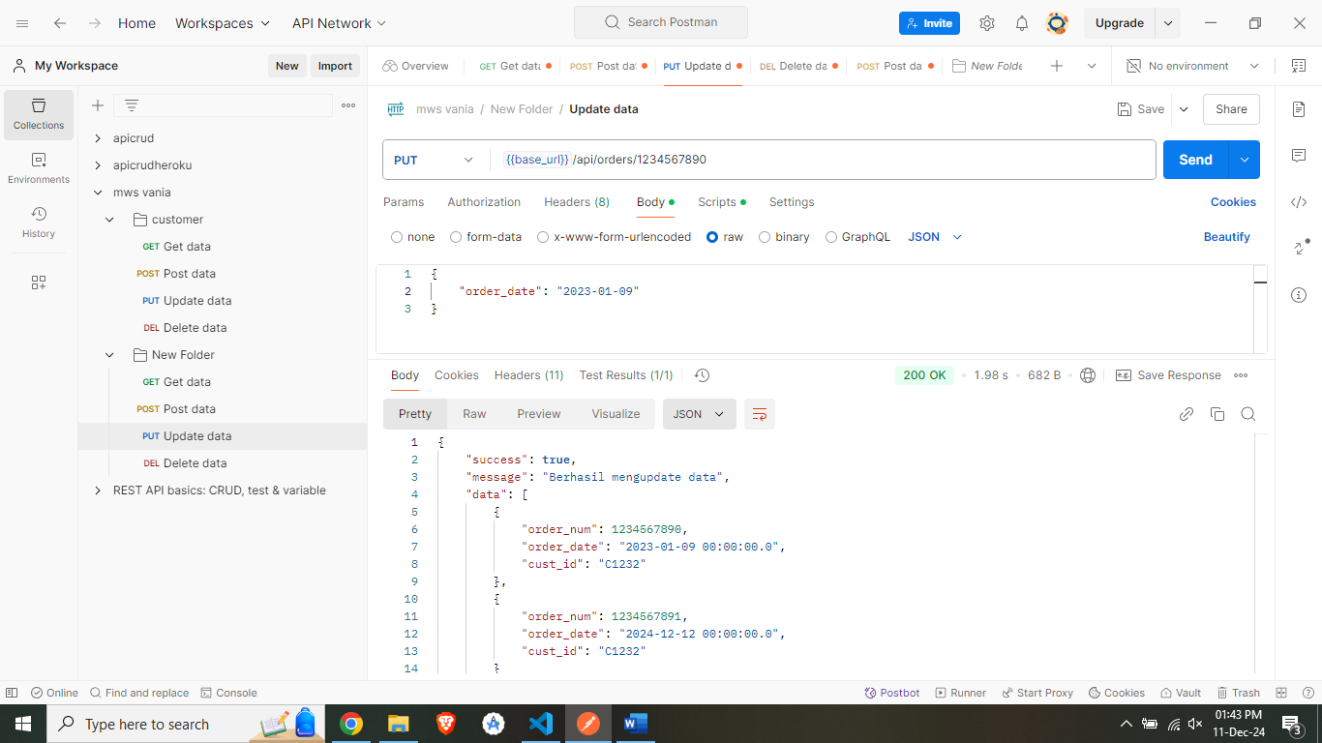

1. Delete

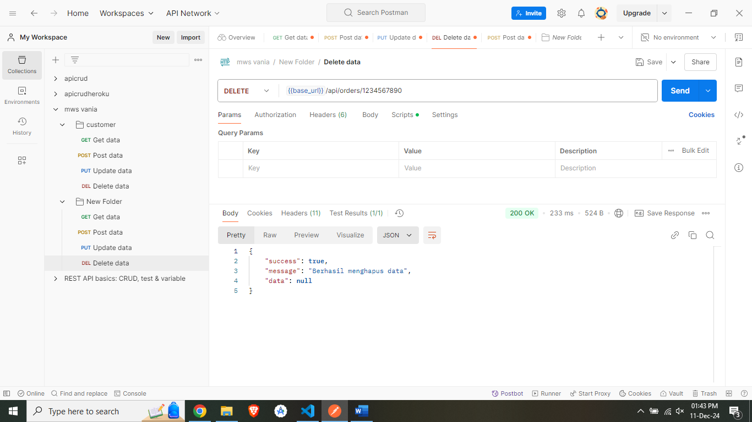

vendors:

1. Create

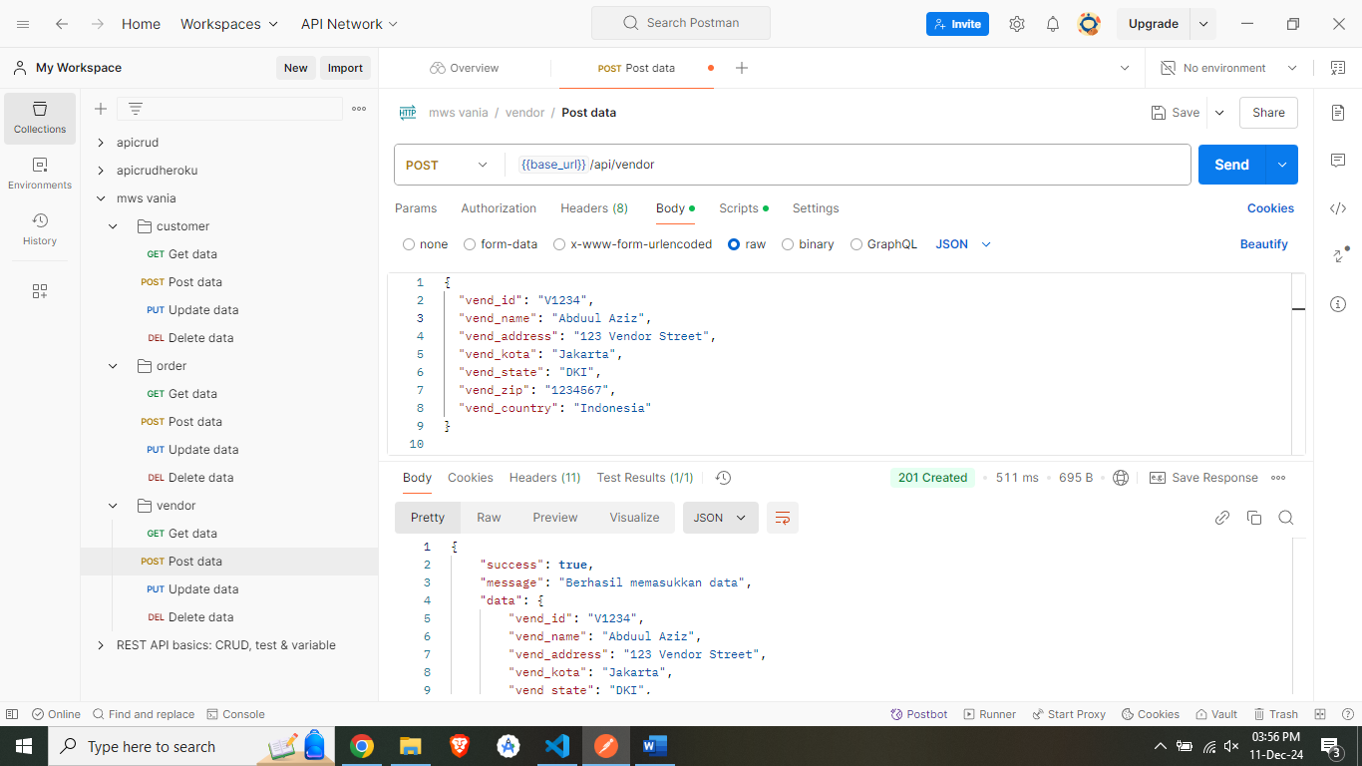

1. Read

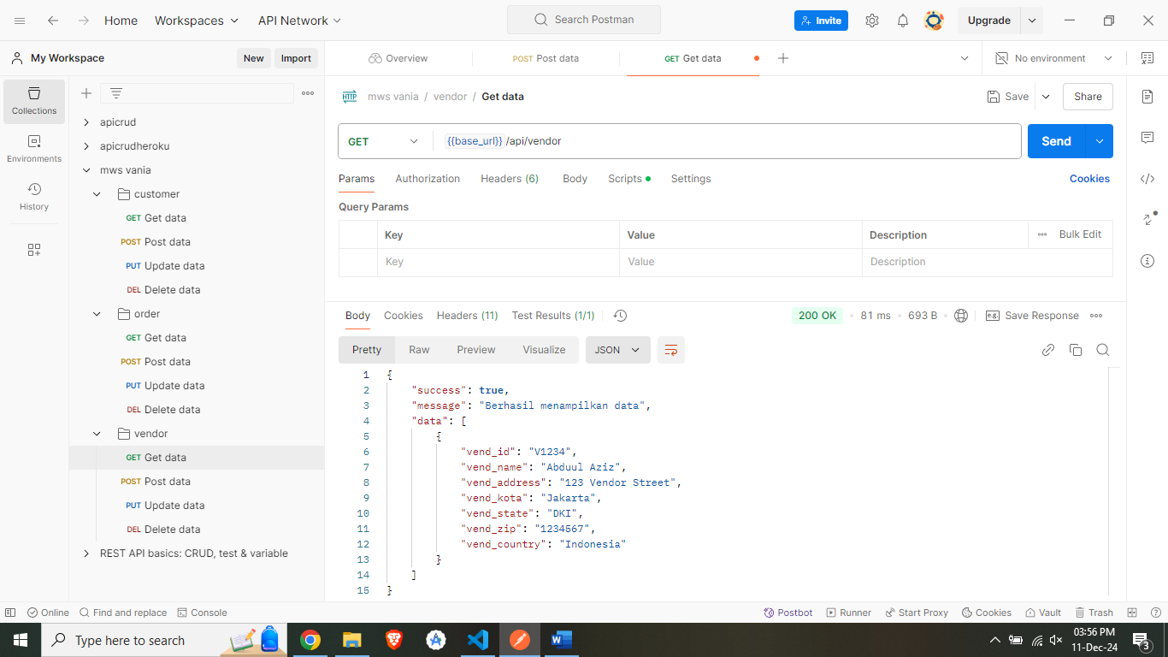

1. Update

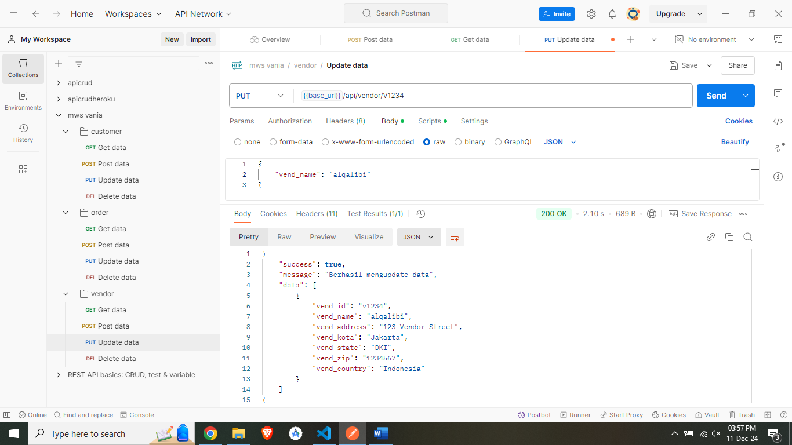

1. Delete

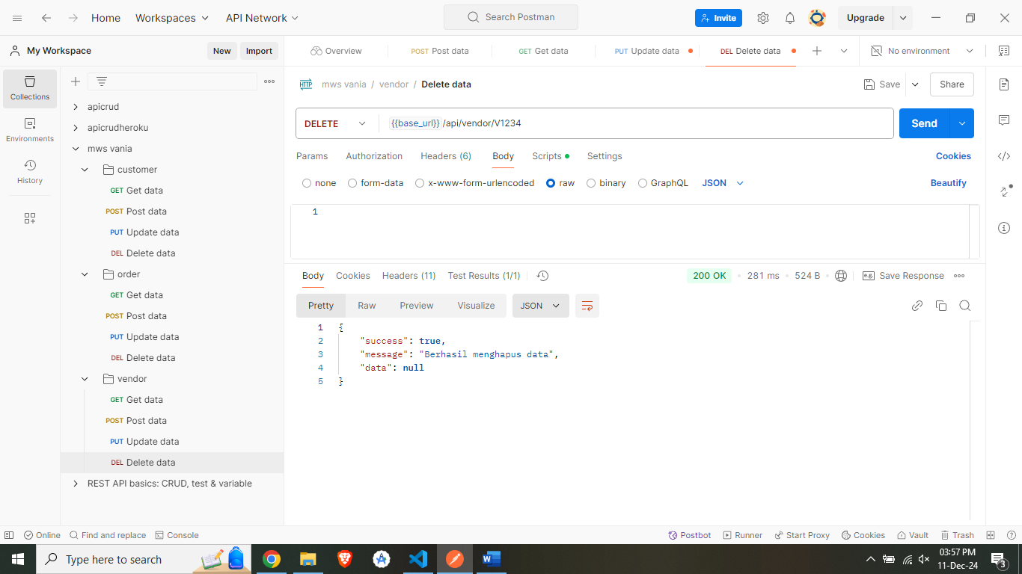

orderitems:

1. Create

1. Read

1. Update

1. Delete

products:

1. Create

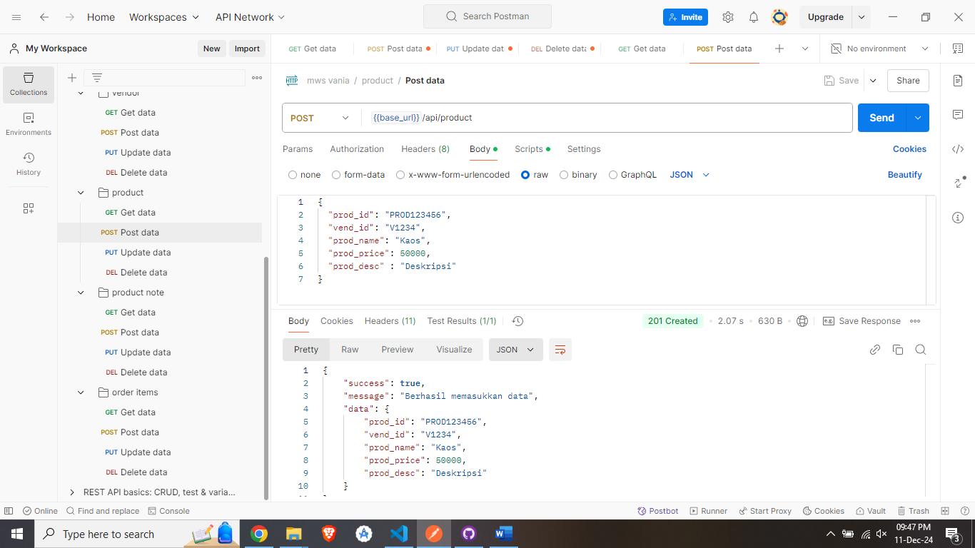

1. Read

1. Update

1. Delete

productnotes:

1. Create

1. Read

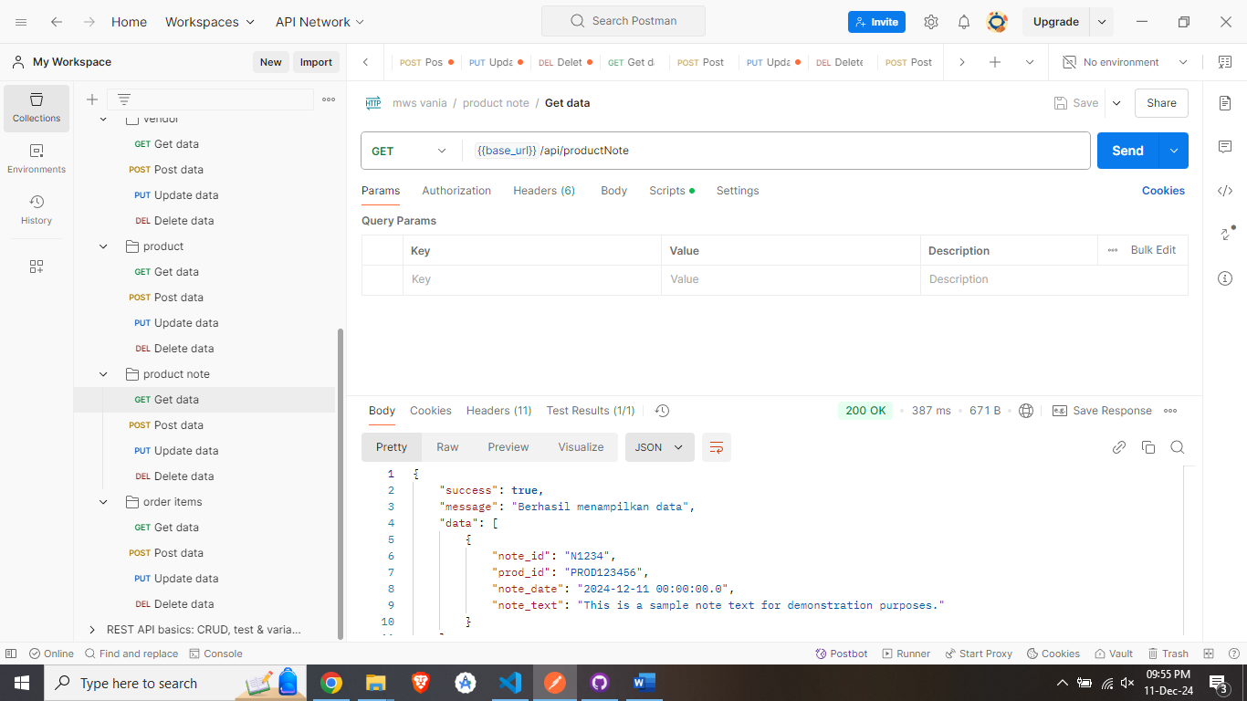

1. Update

1. Delete

